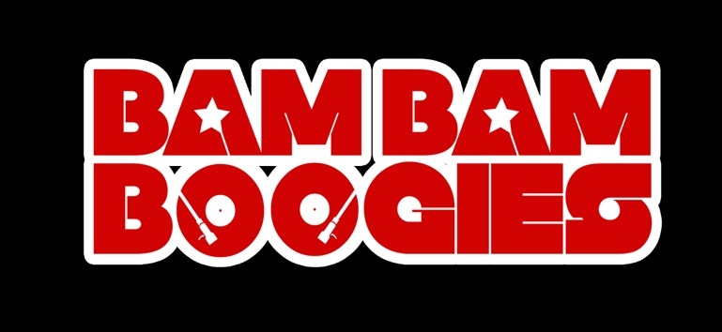
CLASS GUIDELINES / TERMS & CONDITIONS

Please read the Guidelines and Terms & Conditions below so that we can run safely throughout our studio locations. These guidelines have been dictated to the Bam Bam Boogies by the venues we are hiring so we ask our dancers, students & families to please respect so we can operate stress free and there is clarity when attending our classes.

- Sandon Location: The Sandon School, Molrams Lane, Chelmsford, CM27AQ (Dance Studio is on the first floor of the Sports Complex). Classes operate in this location from Monday – Friday (unless stated).
- 3D Studio location: Unit 3D Beehive Business Centre, Beehive Lane, Chelmsford, CM29TE. Classes operate in this location on Saturdays (unless stated).
- Do not arrive at the studio without a prior agreed class booking. Please refer to our payment policy with regards to making sure your class is pre-paid before you attend.
- Arrive ready and prepared for your class approximately 10 minutes before it is due to begin & wearing the clothes you will be dancing in. If you need to change into your dance trainers, this is fine.
- Spectators to classes are unfortunately prohibited, due to the fact that we wish not to distract other class members. Parents of children attending the Bam Bam Bino classes will be invited in at the end of the class to watch them showcase what they have done in class that day.
- Upon exiting the studios, please make sure your space has been cleared and is free from litter & no personal belongings have been left.

PAYMENT POLICY
- Class fees are payable at the start of term. These can either be paid in full or two half termly payments.
- New Students are offered to pay for one class before they sign up to the term, after which they will be billed for the remainder of term. An invoice will be issued the following day / week ready for payment by the half term deadline. We are unable to offer regular free trials but please look out for our taster days / offers etc.
- Upon booking your class space for the term, individual students will be offered a 5% discount if the fee is paid in full by the due date (prior to the term starting), failure to do so will see the discount removed and the class fee will go back to its full price. Families with 2 or more members attending will also receive a 10% discount and you can choose to pay in full or in two half termly payments. Only one discount will be applied per family. All fees must be paid by the half term deadline.
- Payment of fees can be made in person when attending class or via bank transfer to:
Bam Bam Boogies CIC / Account No. 27535364 / Sort Code 23-05-80
Please use either your invoice number or students name as a payment reference.

CANCELLATION POLICY
- Class cancellations due to extreme weather conditions, student absence or sickness (unless long term) will not be refunded.
- Classes cancelled due to Teacher absence / venue unavailability will be rearranged at a later date.

PLEASE NOTE:
- All classes now need to be booked & paid in advance.
- No walk-ins allowed entering the studio
- Cash is still accepted and preferred with regards to Private Lessons / Workshops / Ad-hoc Rehearsals.

